Map

Average Slip to Lap with a Static Toe

Pressure to Core Temperature Graphs & Pressure to Lap

**Front Pressure to Core Temperature**

x = Average core temp of all tyres, y = Front tyre pressure

**Rear Pressure to Core Temp**

**Rear + Front Pressure to Core Temp**

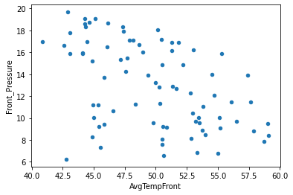

**Front Pressure to Lap Time**

**Rear Pressure to Lap Time**

**Rear + Front Pressure to Lap Time**

Average Slip to ARB (Including Diff Coast)

**ARB_Front to Average Slip**

**ARB_Rear to Average Slip**

**ARB_Front / ARB_Rear to Average Slip**

**Diff Coast to Average Slip**

**ARB_Front * Diff Coast to Average Slip**

**ARB_FrontRear * Diff_Coast to Average Slip**

Suspension Inputs to Average Slip

**Front_Rebound to Average Slip**

